Safe working practise within our school
Staff are expected to adhere to the school’s Code of Conduct and to always maintain a professional manner. All adults have a responsibility to be a positive role model by being respectful, fair and considerate to all by:
- Treating all children equally
- Ensuring that when working with individual children the door is left open, or that you are visible to others
- Respecting a child’s right to personal privacy
- Never allowing abusive peer activities, remarks or gestures
- Never using personal equipment to photograph children
- Never exchanging gifts unless approved by the school
Remember someone else might misinterpret your actions. Be aware your good name is not enough to protect you.
Staff must report any concerns about staff conduct around children to the Headteacher. As in all schools, if there are concerns about the conduct of the Headteacher, then these should be shared with the Chair of Governors. The staff ‘Whistleblowing Policy’ has been discussed and adopted and all staff have access to this document.
Concerns about staff members will be reported to the Local Authority Designated Lead:
Anthony Goble
Tel: 01823 359029
Important Key Contacts
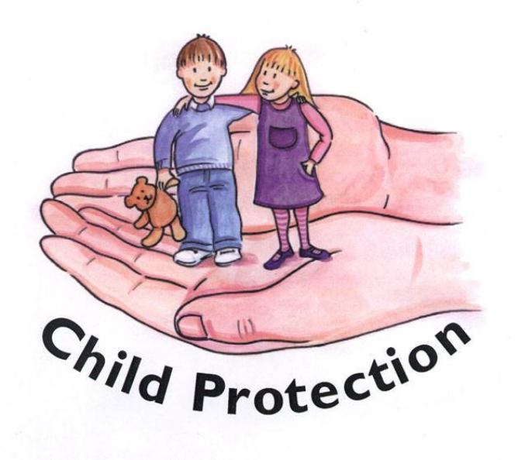
Designated Safeguarding Lead:
Mrs S Watkins
Tel: 01963 220345
Deputy Designated Lead
Mrs H Free
Tel: 01963 220345
Safeguarding Governor
Mr David Horn
At Charlton Horethorne Primary School we are committed to safeguarding and promoting the welfare of children. We expect everyone to share this commitment.

Tel: 01963 220345

Other Useful Contacts
Children’s Social Care Services 0330 123 2224
Police 999
NSPCC 0808 800 5000
ChildLine 0800 1111

Everyone has a responsibility to make sure that children within our school are safe

Safeguarding and

What is Child Protection?
Child Protection is the process of protecting children and young people who have been identified as suffering, or likely to suffer harm as a result of abuse.
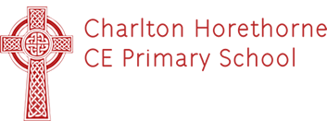

Types of Harm
Physical: Where a child’s body is deliberately hurt or injured, by an adult or other child
Sexual: Where adults use children, or their images, to satisfy sexual desires; other children can also be abusers
Emotional: Where children may be deprived of love, continually shamed and taunted, given responsibility beyond their years, or witness the ill treatment of another
Neglect: A persistent failure to meet a child’s physical, emotional and/or psychological needs
Extremism: The holding of extreme political or religious views
What is Safeguarding?
Safeguarding is the action taken to keep all children safe by:-
* Protecting them from harm
*Ensuring that they are safe and well looked after
*Taking action so that all children are able to grow up in a safe environment
All children have the right to be protected from harm
What are our responsibilities at Charlton Horethorne Primary School
The Designated Safeguarding Lead must ensure:
- That everyone working in our school has successfully completed the necessary clearances to enable them to work with children
- That all staff members are regularly trained to deal with issues around child protection and safeguarding.
- We have staff members and governors who are specifically trained and nominated within the school as the Designated Safeguarding Lead and the Deputy Designated Safeguarding Lead
- We have policies and procedures in place that contribute to our safeguarding commitment
- We follow the Somerset Safeguarding Children’s Board guidance and have systems in place to share concerns regarding children’s welfare with
- We have a visitors’ book which must be signed by all visitors, confirming the nature of their visit.
- All staff and adults have a responsibility to make sure that children at Charlton Horethorne Primary School are safe; all children have a right to be protected from harm.

…………………………
The welfare of children is of paramount importance
What do you have to do if you are worried about a child?
You RECORD AND REPORT:

- Respond without showing any signs of disquiet, anxiety or shock.

- Enquire casually about how an injury was sustained or why a child appears upset.

- Confidentiality must not be promised to children, young people, or adults in this situation.

- Observe carefully the demeanour of behaviour of the child or young person.

- Record in detail what has been seen and heard.

- Do not interrogate or enter into detailed investigations: rather, encourage the child or young person to say what he wants until enough

- Information is gained to decide whether or not a referral is appropriate.

- Then report to the Designated Safeguarding Lead or other specifically trained nominated staff
Doing nothing is not an option.
……………………
Families have a right to expect schools to provide a safe environment for children

